Address of the Head of administration of Derbent to investors

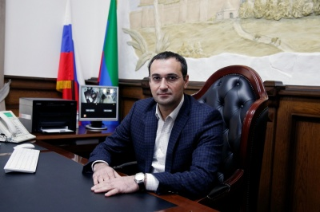
Dear friends!
The history of Derbent accounts more than 5000 years, its architectural monuments – the citadel "Naryn-Kala", the fortifications, the old city with numerous monuments, included in the UNESCO World Heritage List - are the property of world culture. Derbent is the historical center of the spread of Judaism, Christianity and Islam in Russia. For thousands of years, representatives of different nations and religions live in peace and harmony. This is evidenced by the awarding to the city in 2006 of the diploma of the UNESCO Prize "For Contribution to the Development of Tolerance and Non-Violence in Society".
Today Derbent is a city with a dynamically developing economy and social infrastructure, industrial, commercial and transport center of the south of Dagestan. Successes of the city have been repeatedly awarded by the authorities of the Russian Federation and the Republic of Dagestan. We look to the future with confidence, realizing our great potential and available reserves of growth. Derbent in the coming years should be reborn as the center of all-Russian and world tourism. We talk about all this with such confidence due to the talent, hospitality, enterprise of the city's residents, united by one commonality - Derbent people.
The city administration invites potential investors and entrepreneurs with investment projects and initiatives for dialogue and cooperation, we are always ready to meet every entrepreneur, provide practical assistance and ensure transparency, stability, security of each project. The most favorable conditions for doing business will be created for you.
Our goal is to develop the city's economy, increase revenues to the local budget, and improve the quality of life of citizens and visitors. Of course, all our plans can be realized only together with you and for you, dear friends! We will always be sincerely glad to act for you in the role of hospitable hosts. We invite you to mutually beneficial and active cooperation.

Yours faithfully,

Rustambek Pirmagomedov
Head of administration of Derbent

